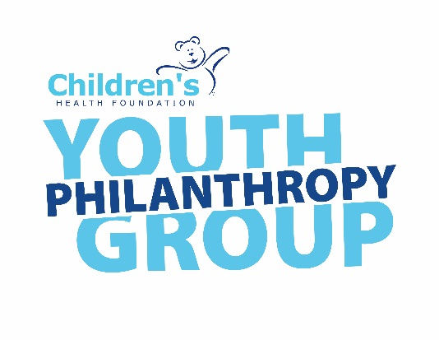
Children’s Youth Philanthropy Group
2023-2024 Membership Application Form

Parent/Guardian: Please complete Part A and Part E of this form, for applicants under the age of 18.

Youth Applicant: Please complete Parts B, C, D and F of this form, and return the completed application to the Children’s Health Foundation.

Part A- Parent/Guardian Contact Information:
First Name:__________________________ Last Name:_____________________________

Email:_____________________________________________________________________

Home Phone:________________________ Mobile:_________________________________

Part B- Youth Applicant Contact Information:
First Name:___________________________ Last Name:____________________________

Email:_____________________________________________________________________

Home Phone:__________________________ Mobile:_______________________________

Mailing Address:_____________________________________________________________

School:_______________________________________ Grade:________ Age:___________

Part C- Youth Application Information
- Why do you want to be a member of the Children’s Youth Philanthropy Group?

- Tell us about any past and current volunteer experience.

- What other experience would you bring to the Youth Philanthropy Group?

- Are you able to attend bi-weekly meetings from September-May? Typically, meetings will be held Monday-Friday in the early evenings and would be 1.5 hours in length.

- Additionally, members will be asked to join a sub-committee (Event Logistics, External Relations, and Marketing/ Communications). It is mandatory to also attend sub-committee meetings. Will you be able to commit to attending these meetings as well? (Note: these meetings dates and times will be selected based on what works for the majority of sub-committee members)

- What are your other commitments during the time frame of September-May (job, volunteer, school, etc.)?

- How did you hear about Children’s Youth Philanthropy Group?

Part D- References (Please let your references know we may be contacting them)
Reference #1

Name:__________________________________ Email:______________________________

Relationship:________________________________________________________________

Reference #2

Name:__________________________________ Email:______________________________

Relationship:________________________________________________________________

Part E- Parent/ Guardian Signature
I understand that the Children’s Health Foundation may contact my child regarding the Youth Philanthropy Group, and that if my child is selected, they will be required to attend regular meetings at the Children’s Health Foundation and/or virtually through Zoom.

Parent/Guardian Signature________________________________ Date: ________________

Part F- Youth Applicant Signature
I understand that if selected to join the Youth Philanthropy Group, I will be required to attend and participate in regular meetings, as well as commit to a one-year term on the committee.

Youth Applicant Signature___________________________________ Date: _____________

Thank you for your interest in supporting the Children’s Health Foundation through the Youth Philanthropy Group!

Please send your completed application to Ashley Thorne at volunteer@childhealth.ca

